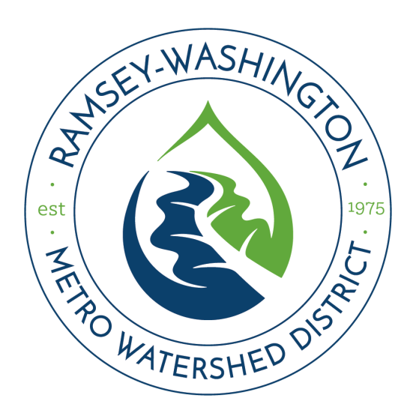

Stormwater Operations & Maintenance Plan

Project Name:
RWMWD Permit Number:
Date:
The project escrow will not be refunded until a final, as-built O&M plan has been submitted, and a final inspection by District staff verifies all conditions of the permit have been met.
For reference, a template prepared by Carver County Water Management Organization is available on www.rwmwd.org/permits

Appendices

Executed Maintenance Agreement
Template available on www.rwmwd.org/permits
Note: For projects located in Maplewood or Roseville, a joint agreement is required (also available online).

Project Information
Legal description, maintenance contact (name, phone number, e-mail), project description including a summary of stormwater facilities and associated pretreatment methods

Inspection and Maintenance Schedule
Inspection and maintenance tasks, estimated month/year of completion, person(s) or department(s) responsible for completion

Inspection Checklist
Must be specific to the facilities constructed onsite and include marked utility plans, construction details, typical cross-sections, planting plans, and plant ID information if applicable.

Maps, Photos
Project location map, site aerial photo with facility locations marked including inspection and pretreatment/clean-out locations if applicable, photo(s) of constructed facility once completed and vegetated, if applicable.

